Ideation Phase
Brainstorm & Idea Prioritization Template

Date | 03-10-2026
Team ID | SWTID-2026-8713
Project Name | Implement Client Script & UI Policy (Incident)
Maximum Marks | 4 Marks

Brainstorm & Idea Prioritization Template:
Brainstorming provides a free and open environment that encourages everyone within a team to participate in the creative thinking process that leads to problem solving. Prioritizing volume over value, out-of-the-box ideas are welcome and built upon, and all participants are encouraged to collaborate, helping each other develop a rich amount of creative solutions.
Use this template in your own brainstorming sessions so your team can unleash their imagination and start shaping concepts even if you're not sitting in the same room.
Reference: https://www.mural.co/templates/brainstorm-and-idea-prioritization

Step-1: Team Gathering, Collaboration and Select the Problem Statement
Selected Problem Statement:

A ServiceNow administrator needs to dynamically control Incident form fields so that selected fields become mandatory, read-only, or visible when defined Incident conditions are met. Without this behavior, users may enter incomplete information, edit protected fields, or see unnecessary fields.
Project Focus:

Implement Client Scripts and UI Policies on the Incident table to improve form usability, enforce consistent data-entry practices, and dynamically respond to user actions and Incident conditions.
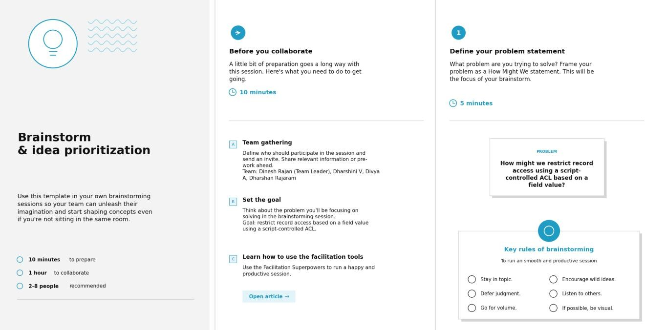

Step-2: Brainstorm, Idea Listing and Grouping

Brainstormed Ideas:

- Create a UI Policy to make selected Incident fields mandatory when a condition is met.

- Create a UI Policy to make selected Incident fields read-only when a condition is met.

- Create a UI Policy to show or hide selected fields based on Incident conditions.

- Use a Client Script to dynamically change field behavior when a user changes a value on the Incident form.
- Apply rules to relevant Incident fields such as State, Category, Subcategory, Assignment Group, and Resolution/Close Notes.
- Provide immediate form behavior without requiring the Incident record to be submitted.

- Test Client Scripts and UI Policies using different Incident states and field combinations.

- Check that mandatory, read-only, and visibility rules do not conflict.

Idea Grouping:

  - Mandatory Control – ensure required Incident information is entered.

  - Read-only Control – prevent inappropriate modification of fields.

  - Visibility Control – display relevant fields only when needed.

  - Dynamic Interaction – use Client Scripts for client-side responses to field changes.

  - Validation & Testing – verify consistent behavior across Incident conditions.

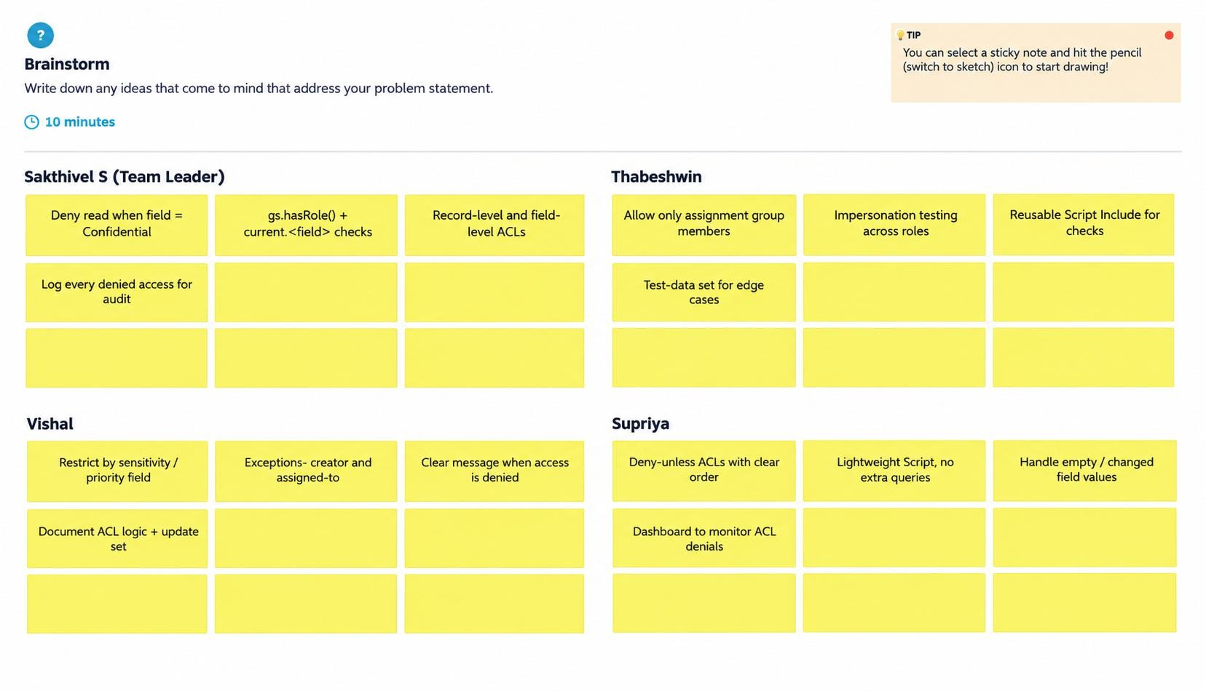

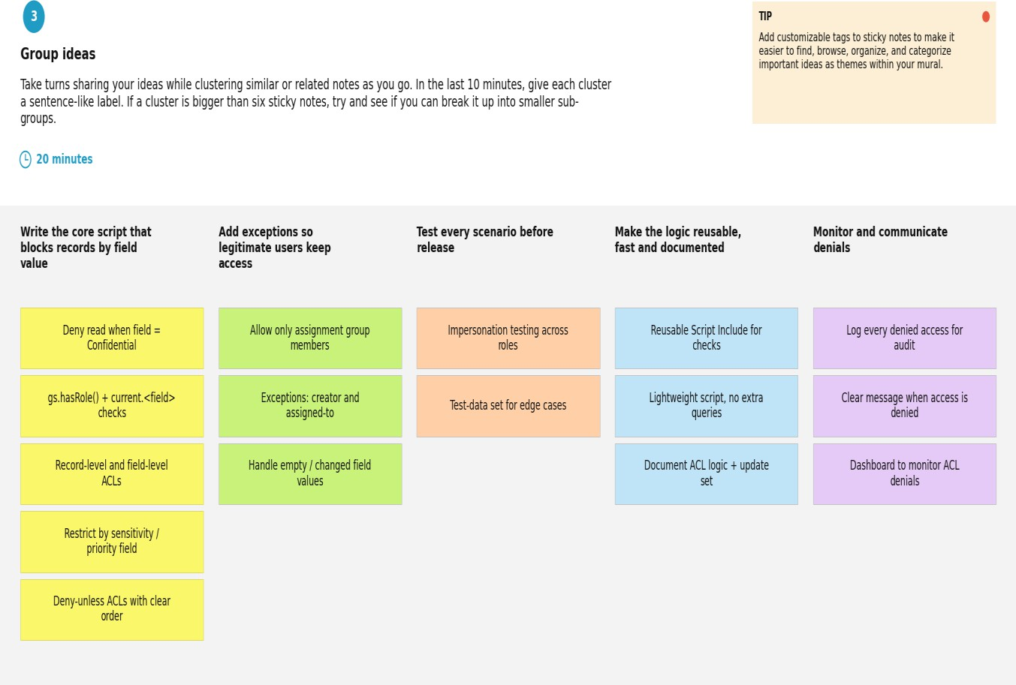

Step-3: Idea Prioritization
Prioritized Ideas:

- Configure UI Policies for mandatory, read-only, and visibility behavior.

- Implement Client Scripts for dynamic field behavior that requires client-side logic.

- Test the rules across different Incident states and user actions.

- Review the form for conflicting or unnecessary field rules.

- Provide clear and consistent data-entry behavior for service desk users.

Priority Rationale:

Field control is the highest priority because it directly supports the project objective. Client-side interaction and testing follow to ensure that the Incident form responds correctly and consistently.
Final Selected Solution:

Use a combined Client Script and UI Policy approach on the Incident table. UI Policies will control mandatory, read-only, and visible behavior when defined conditions are met, while Client Scripts will handle dynamic client-side interactions that require additional logic.
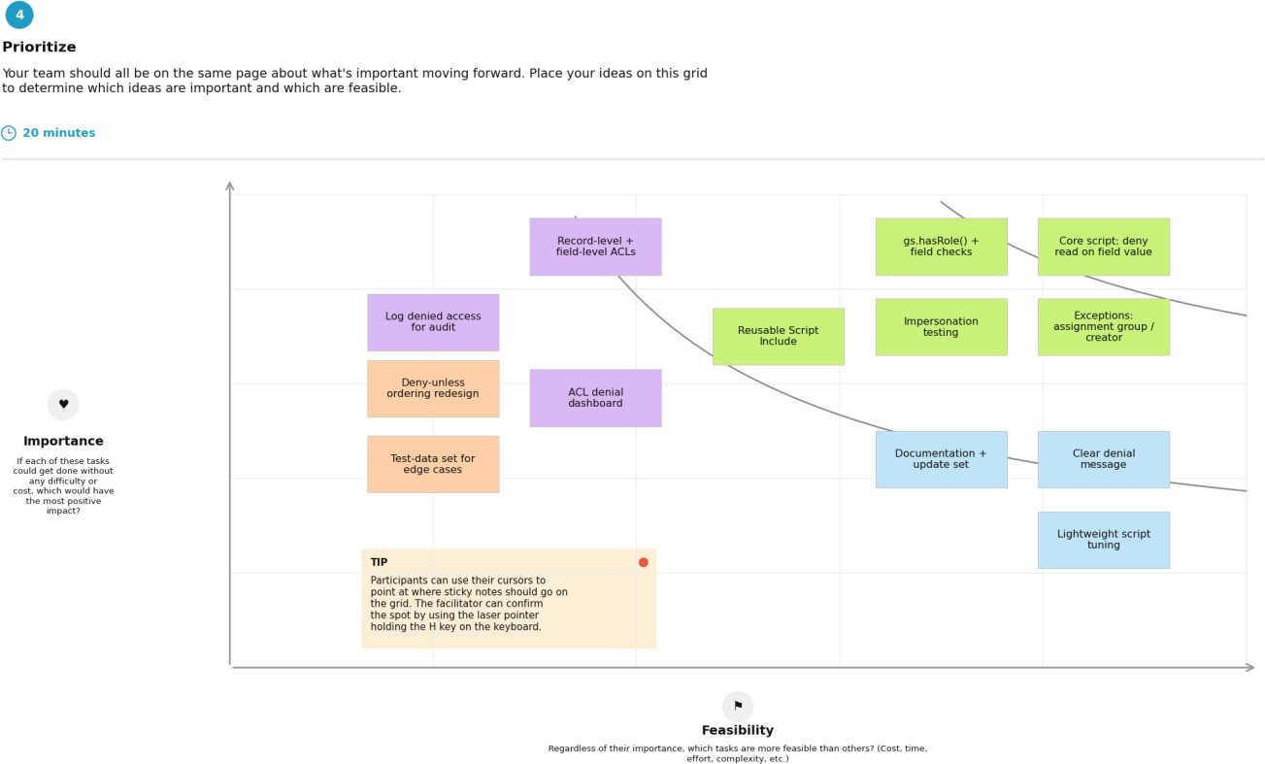

Sticky-note colours: green = high importance and high feasibility (do first); purple = high importance, lower feasibility (plan next); blue = lower importance, high feasibility (quick wins); orange = lower importance and feasibility (reconsider).

Project Task Assignment – Milestones

Milestone (Epic) | Task | Assigned to | Time | Level | Status
Milestone-1: Incident Form Configuration | Identify Incident fields and conditions | Vishal | 30m | Easy | To do
Milestone-2: UI Policy – Mandatory Fields | Configure UI Policy to make selected fields mandatory | Thabeshwin | 45m | Easy | To do
Milestone-3: UI Policy – Read-only Fields | Configure UI Policy to make selected fields read-only | Thabeshwin | 45m | Easy | To do
Milestone-4: UI Policy – Visibility | Configure UI Policy to show/hide selected fields | Supriya | 45m | Easy | To do
Milestone-5: Client Script | Implement dynamic Incident field behavior | Supriya | 1h | Medium | To do
Milestone-6: Testing & Validation | Test conditions, field behavior and user actions | SakthivelS | 1h | Medium | To do
Milestone-7: Conclusion | Document project outcome and verify consistent data entry | Sakthivel S | 30m | Easy | To do

